* Login Form

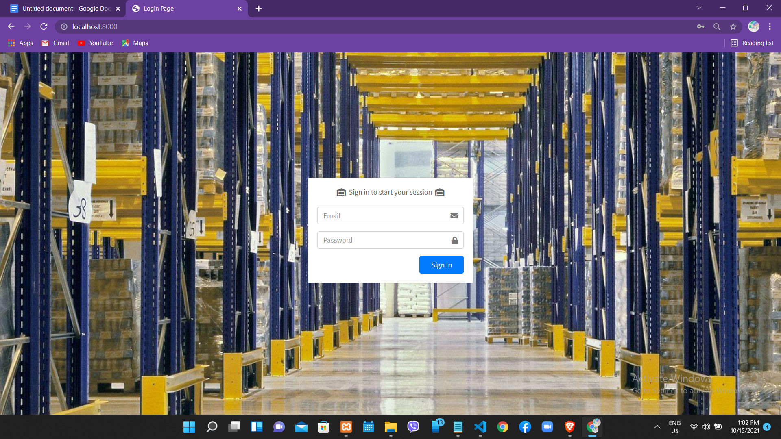

Fig 1.1

You will Login with your email and password that you have in this system…

In this System,There are three role user

1. Project Manager
2. Warehouse Supervisor
3. Regional Warehouse Supervisor

* Project Manager Account

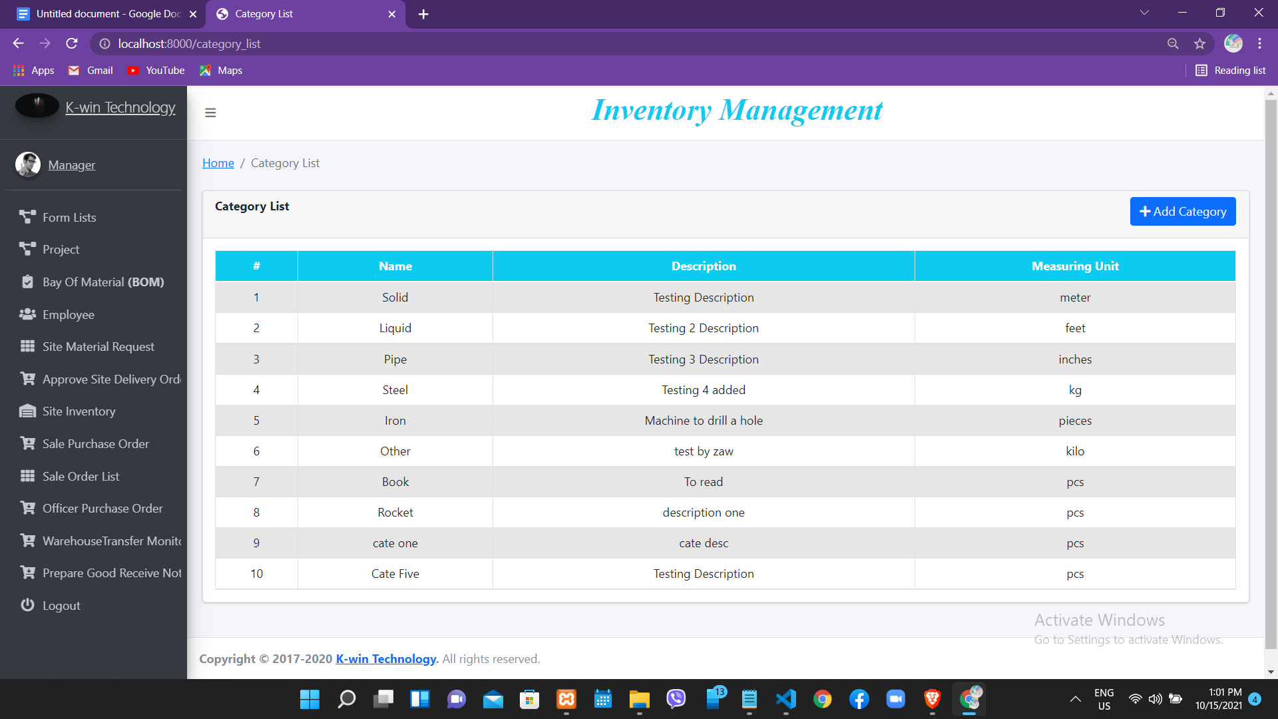

Fig 1.2

Fig1.2, This Figure is the first page when you log in with Project Manager Account..

And then You will see first Category List of product in your Inventory

* Project List

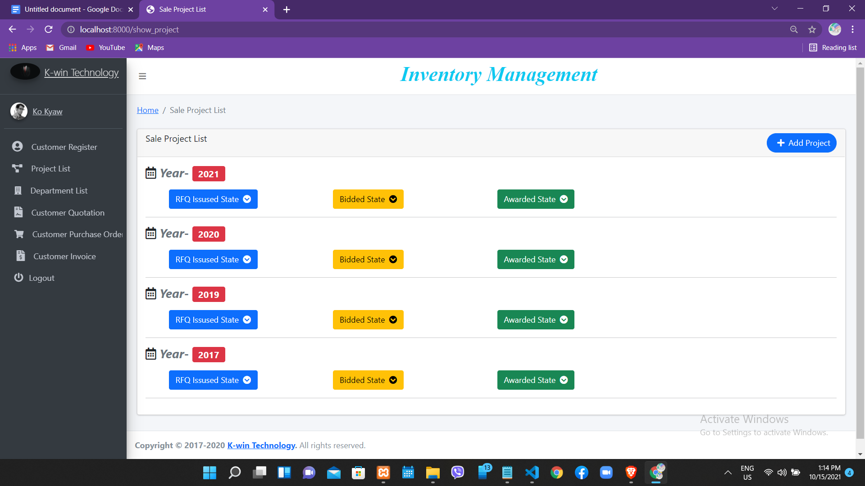

Fig 1.3

Fig 1.3,This figure show project lists collection according to year when you click project list module in navigation side bar

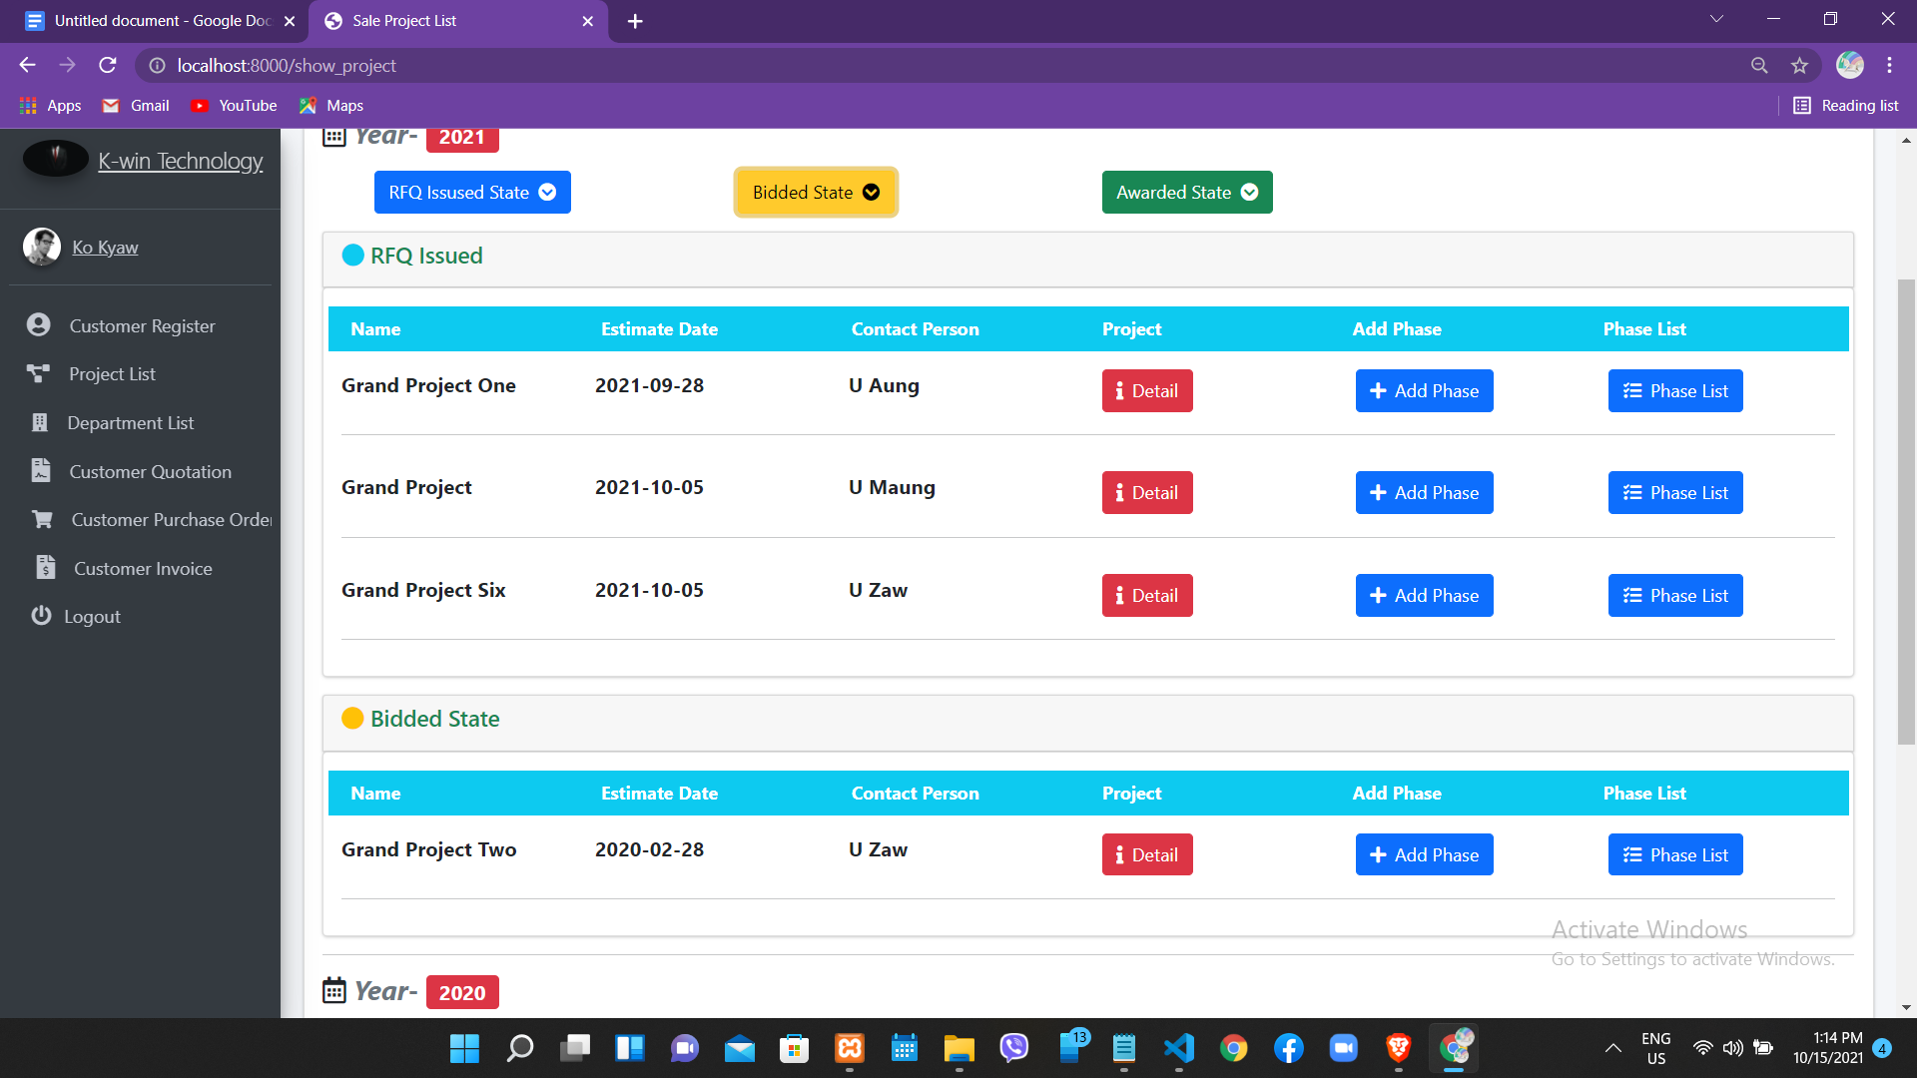

Fig 1.3.1

Fig 1.3.1,This Figure will show project detail information if you click associated button

and drop detail of project with expanded design

* Bay of Material List (BOM List)

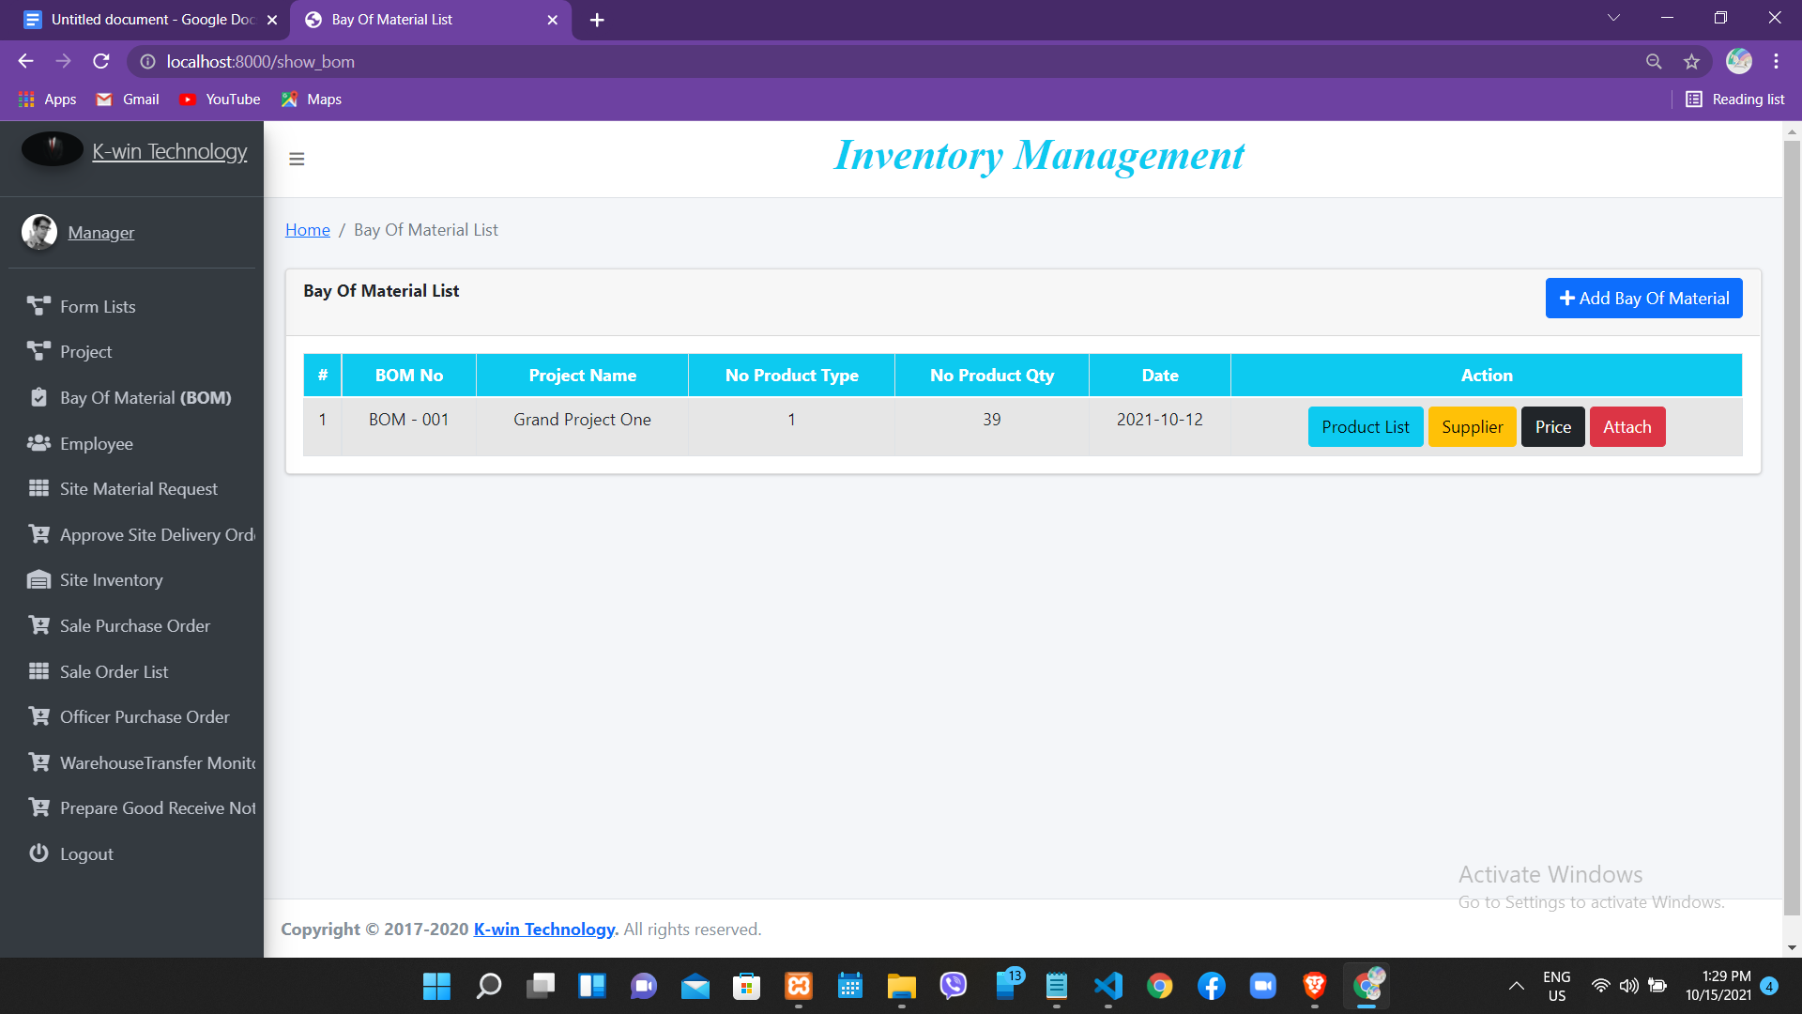

Fig 1.4

Fig 1.4,This Figure will show Bay of Material List and there are six field name

1. BOM No
2. Project Name
3. Number of Product Type
4. Number of Product Quantity
5. Bom Create Date
6. Action (four function)

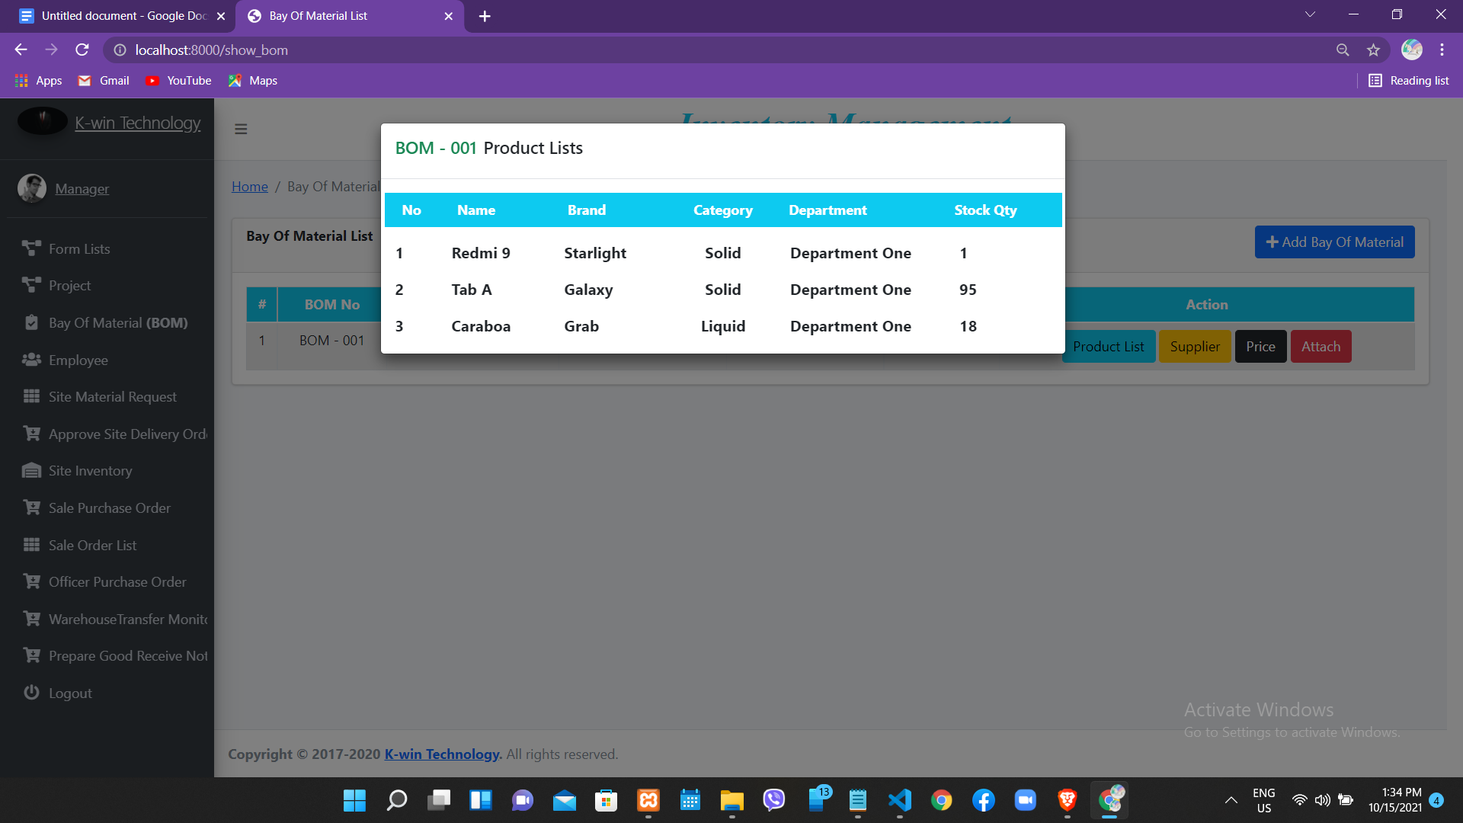

Fig 1.4.1

Fig 1.4.1,This figure will show Request Product List of BOM ,There are five field name

1. Product Name
2. Brand
3. Category
4. Department
5. Stock Quantity

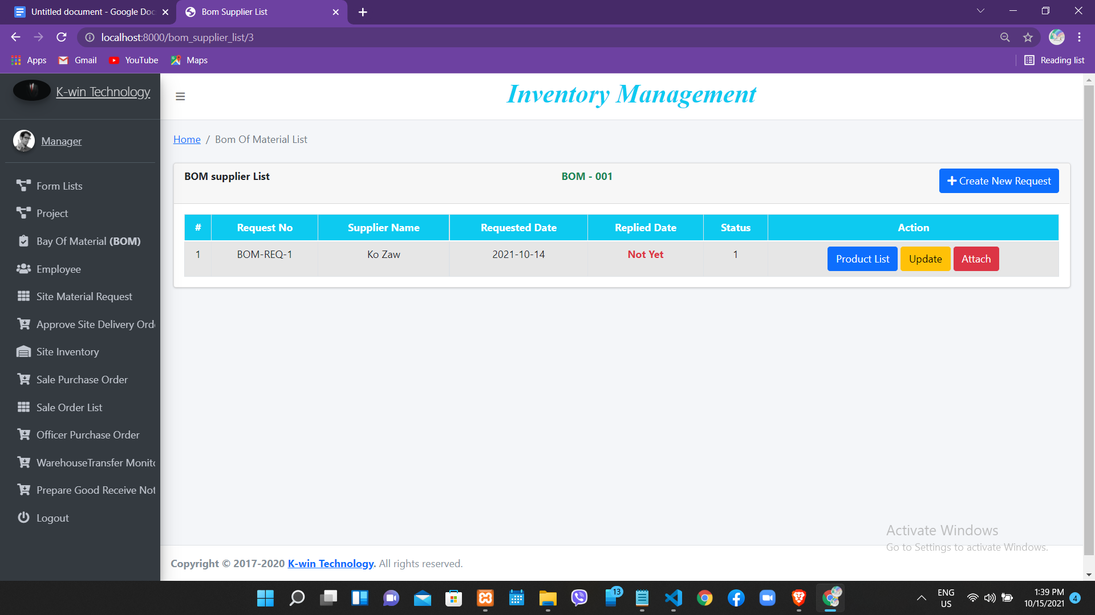

Fig 1.4.2

Fig 1.4.2,This page mean supplier list of BOM and include add new request button on the right of the top corner to register new request to Supplier.You can go this page if you click supplier button of Action field name in Fig 1.4.1

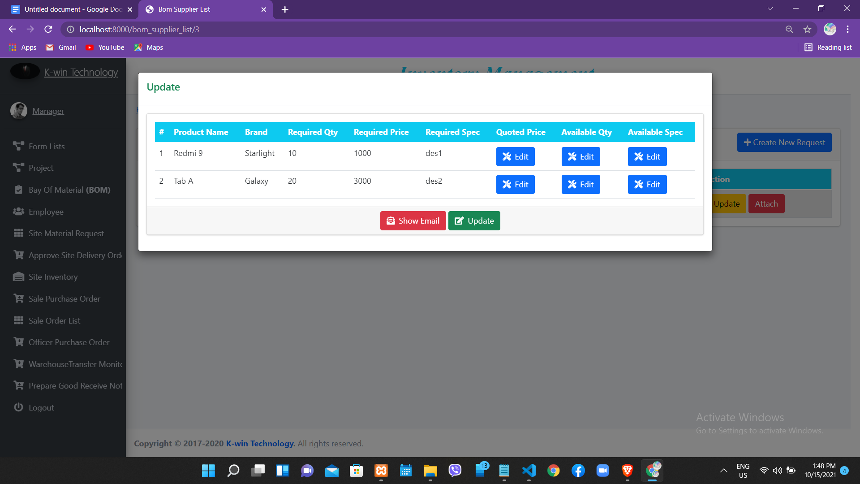

Fig 1.4.3

Fig 1.4.3,This pop up box show the product list of request to supplier and edit quoted price,available qty and available Specification from coming Supplier

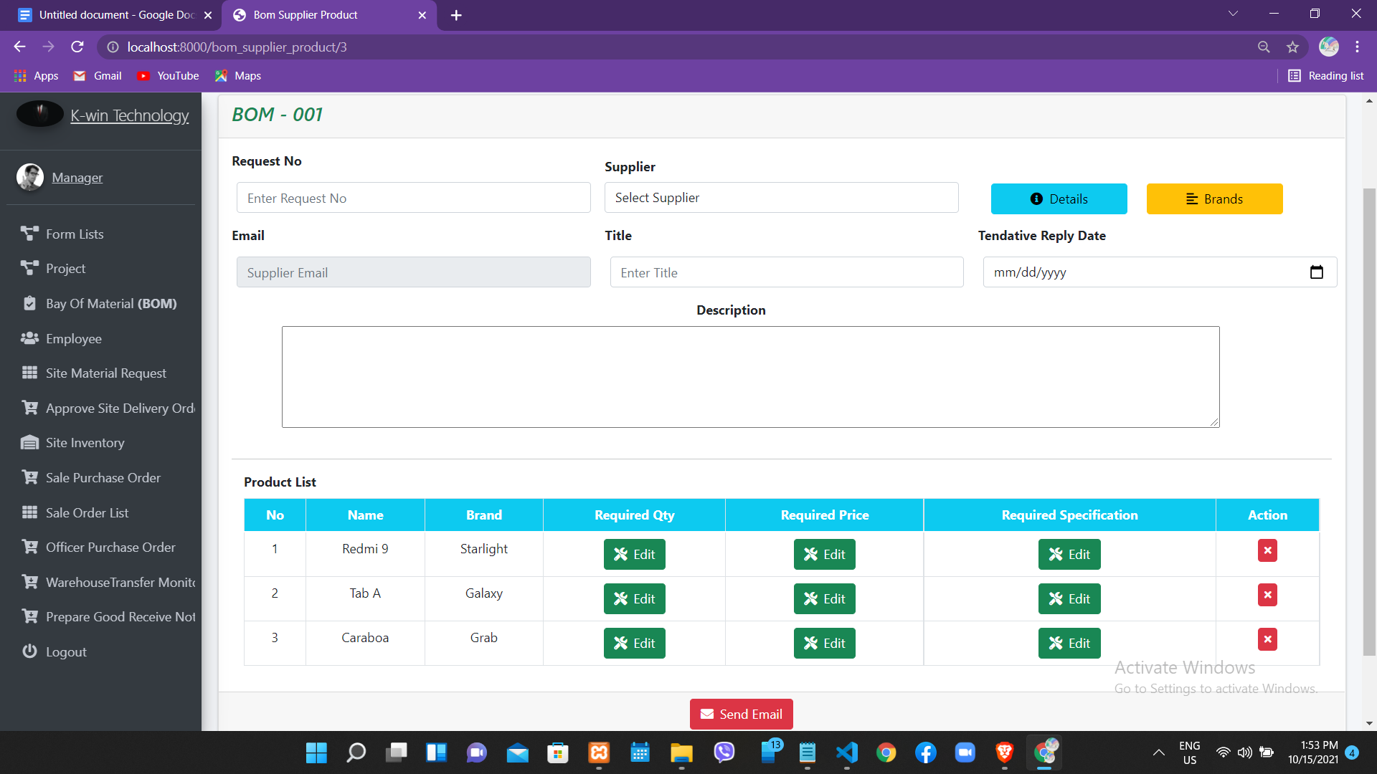

Fig 1.4.4

Fig 1.4.4,This page is the Supplier Request Form of each BOM and you can edit required qty,required price and required Specification and delete unnecessary product to know Supplier’s Price by sending email

* Warehouse Supervisor Account

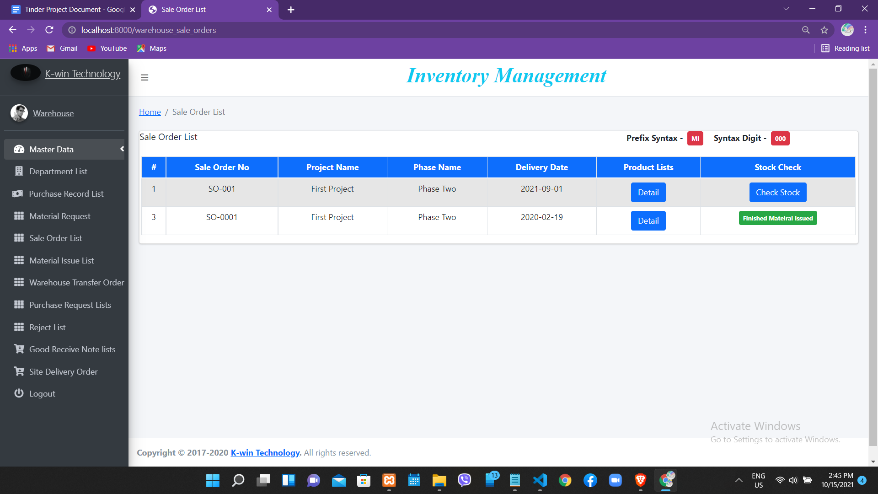

Fig 1.5

Fig 1.5,This is the first page of Warehouse Supervisor Account Panel and then this show

Sale order list who create by project manager .There are Six field name

1. Sale Order No
2. Project Name
3. Phase Name
4. Delivery Date
5. Product List
6. Stock Check (function)

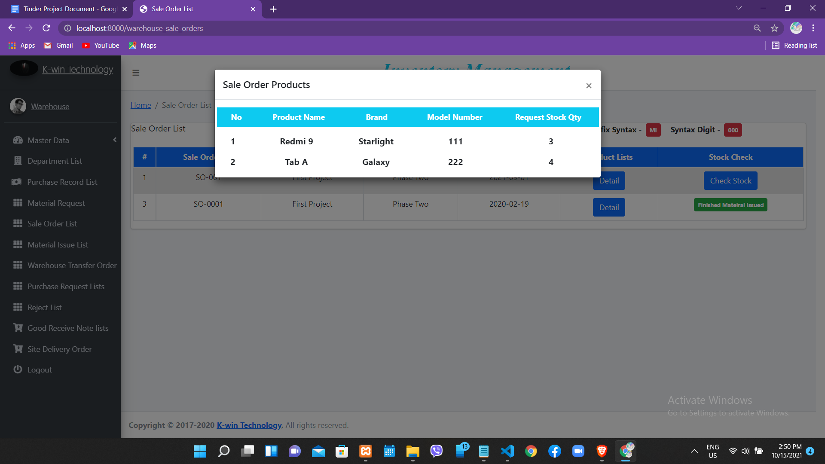

Fig 1.5.1

Fig 1.5.1,This modal box is the product list of sale order that is appear when you click details button of Product Lists field name

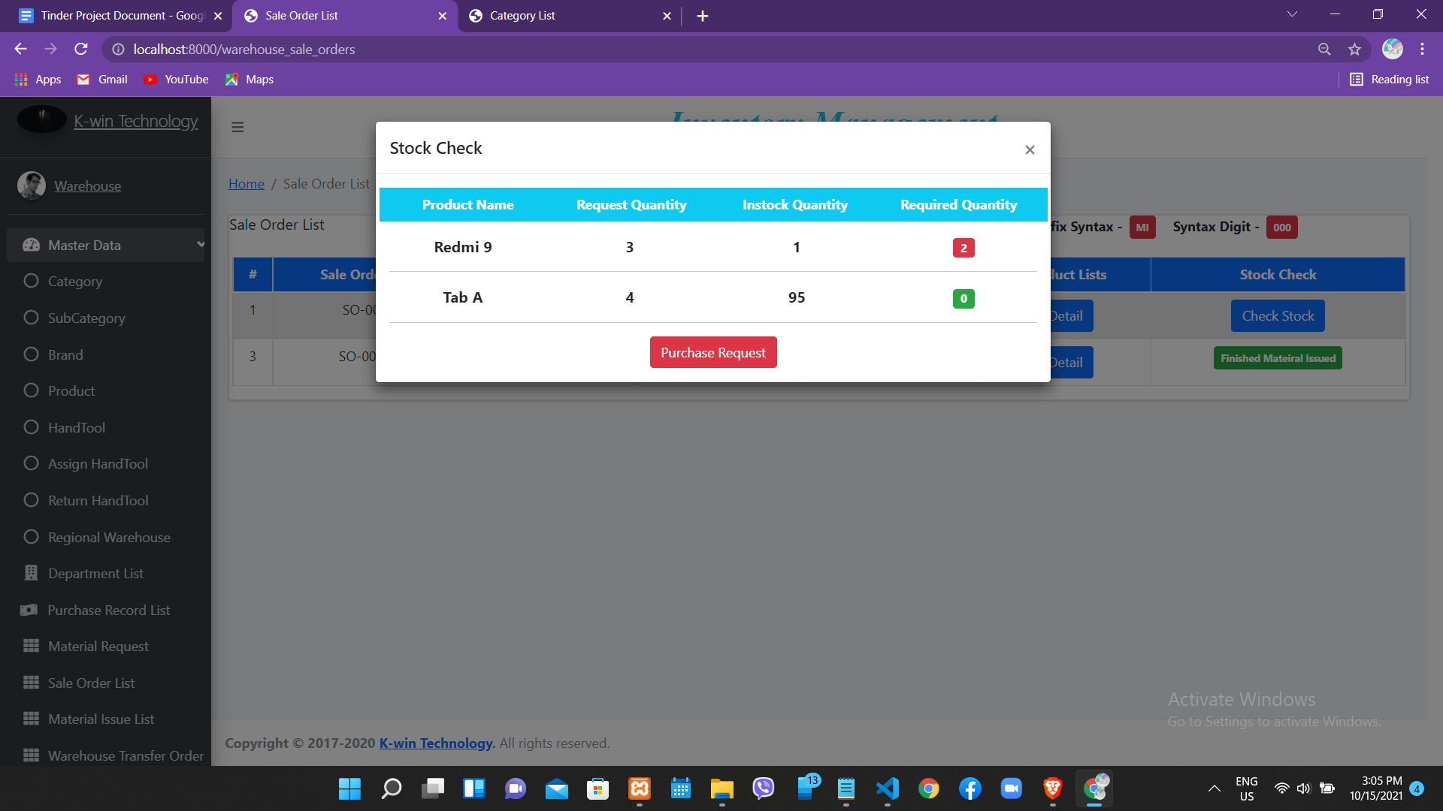 Fig 1.5.2

Fig 1.5.2,This pop up box will show when check stock button to request for purchase or to release as material issue of products that include in sale order list.The red badge that above figure is appear when request qty of product in your inventory is less than required quantity of Sale Order.If it have

only one red badge,purchase request button with red color appear and it not have red badge

And all green badge in Required Qty field ,Material Issue button will appear.

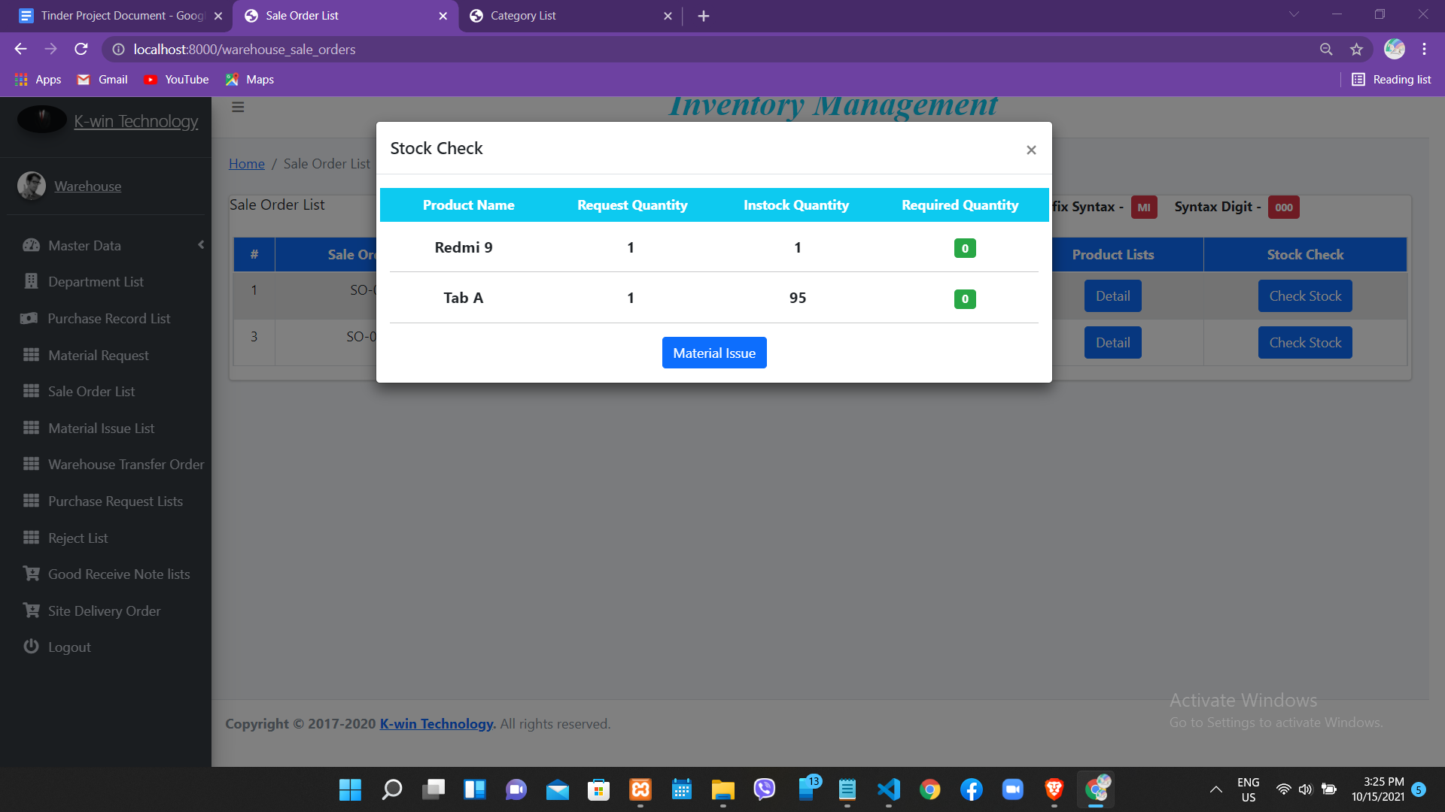

Fig 1.5.3

Fig 1.5.3,This situation is all request product of sale order have in inventory and so it not have only one red badge and then Material Issue button will appear.In figure 1.5.2,It is not enough product qty in inventory situation and so the Purchase Request Button appear.

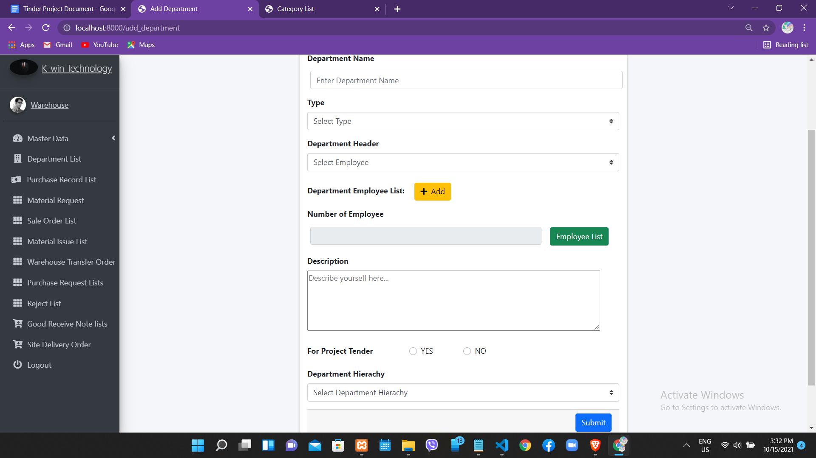

Fig 1.6

Fig 1.6 ,The above page figure that you see is the department register to add new department and it include department name,type,department header,add new department employee (can add one or more employees) and you can view employee list that is you add in employee list button,description,and you choose project type that is tender or normal,and

department hierarchy

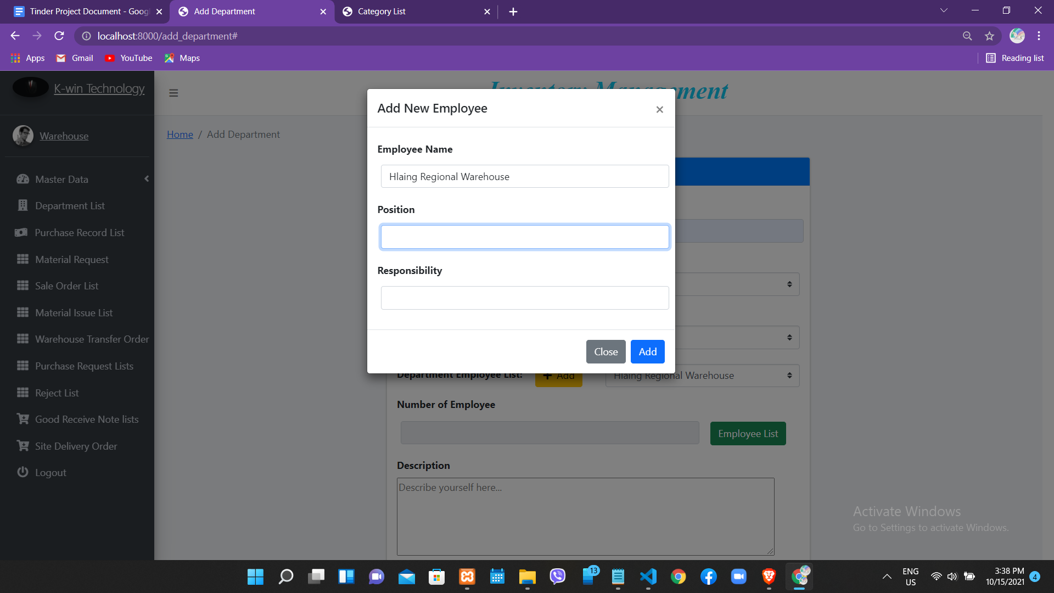

Fig 1.6.1

Fig 1.6.1 ,This modal box is appear when you add a new employee and fill position and responsibility of this employee that you add .

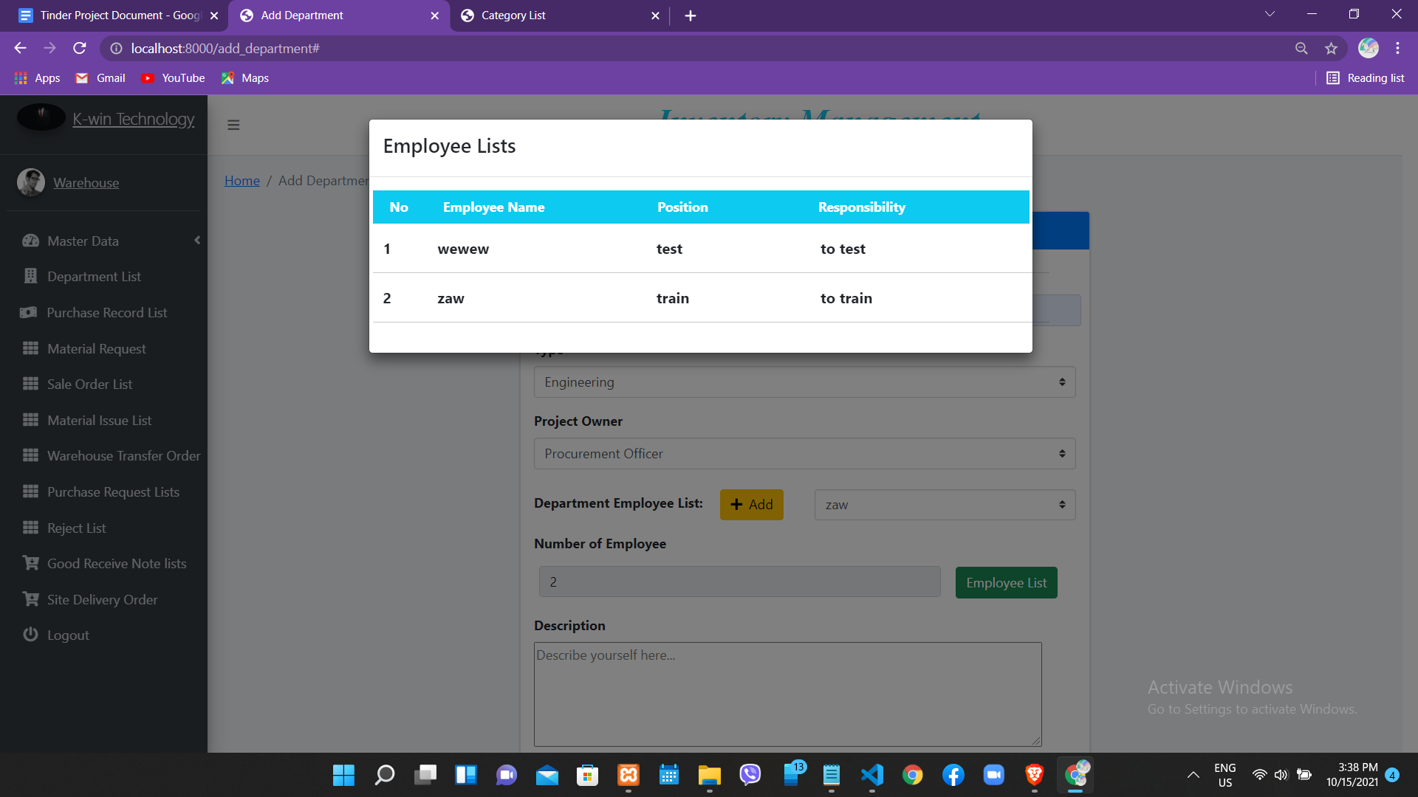

Fig 1.6.2

Fig 1.6.2 , When you click Employee List button with green color and then the modal box with employee list at above figure that is appear.This list is the department employee list.

You can view this after add a new department employee with position and responsibility.